REQUEST FOR ARTWORK
UNESCO City of Media Arts SXSW Exhibition
Artwork Budget: not to exceed $4,000
Deadline to Apply: October 19, 2018; 5:00 p.m. CST

The UNESCO Austin City of Media Arts Steering Committee, in partnership with the Cultural Arts Division within the Economic Development Department, invites professional artists who work in the media arts field (including but not limited to digital arts, film, music, visual and performing arts) from the fourteen UNESCO Media Arts cities to propose an existing or new artwork for inclusion in the international United Nations Educational, Scientific, and Cultural Organization (UNESCO) Media Arts Exhibition to be held during the SXSW Festival and Conference between March 8-17, 2019. Full information about UNESCO City of Media Arts at www.austintexas.gov/mediaartscity.

UNESCO Media Arts Exhibition at South by Southwest (SXSW) 2019
The City of Austin, the only U.S. city with a UNESCO Media Arts designation, is home to South by Southwest (SXSW), an annual festival and conference showcasing the talent and innovation of interactive, music, and film industries from around the globe. In 2016, SXSW’s core events attracted a record 87,971 registrants from around the world, and injected $325.3 million into Austin’s local economy. Full information about SXSW can be found at www.sxsw.com.
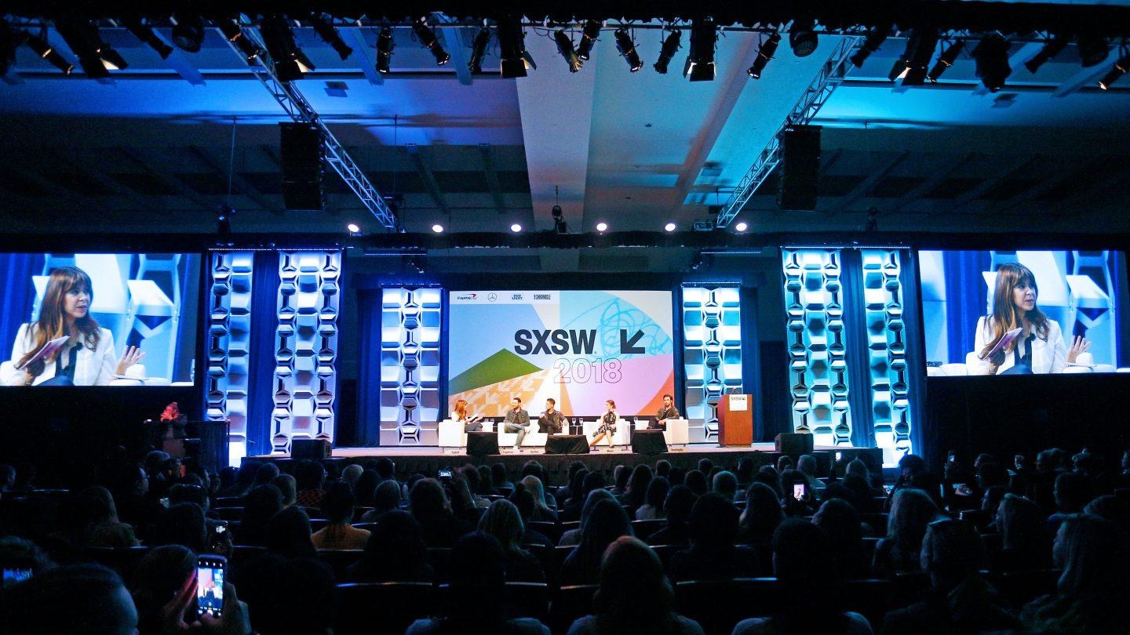
As a UNESCO Creative Cities Network (UCCN) member and contributing Media Arts City, the City of Austin is committed to fostering and showcasing art and innovation across disciplines from across the globe. To further those efforts, the City is partnering with SXSW to continue the annual SXSW UNESCO Media Arts Exhibition.

This call for proposals is directed to the fourteen UNESCO Media Arts cities, including Austin artists, providing an international platform for media arts. The exhibition will feature artwork/installations from several UNESCO media arts cities and may also include programming such as panel discussions with representatives from Austin and abroad. An opening reception will also be organized to further market the Exhibition to SXSW participants.

Location of the UNESCO Media Arts Exhibition
The exhibition will be hosted in a 2,800 square foot gallery in the City of Austin’s new Central Library in downtown Austin—recently hailed by Time Magazine as one the “100 Greatest Places in the World.” Near the heart of the SXSW festival footprint, the gallery will provide maximum visibility of the installations to conference attendees.

Opportunity and Eligibility
The UNESCO Steering Committee will select a total of 3 – 5 art works (or more, depending on size of selected proposals) from UNESCO Creative Cities of Media Arts. Signage and marketing for each selected installation will be provided by SXSW as part of the SXSW Festival. The exhibition will be hosted in a 2,800 square foot gallery in the City of Austin’s new Central Library in downtown Austin.

Artwork criteria:

- Artwork must fit within a space no larger than 12 feet wide x 12 feet long x 9 feet high;
- More than one artwork may be exhibited in a room or space; artist will be responsible for arranging for temporary walls or pipe and drape, if needed;
- Electricity is available for interior artworks (US standard voltage is 120 V, frequency is 60 Hz.);
- If sound is integral to the artwork, decibel levels will be need to be adjusted per SXSW staff expectations was work is on site. Expect decibel levels will be required to remain under 80.
- Artist will confirm lighting needs – Are windows allowing daylight into the space acceptable, or required? Is a darkened space needed? Black-out space? Is standard interior lighting acceptable?
- Artwork must be free-standing; it cannot be leaning, hung, or attached to walls or floors
- Outdoor artwork will be considered, but there is currently no venue to display it; this may change as the exact locations of the exhibition are confirmed. Electricity may not be available.
- For artists requiring accommodations, please include an addendum with your request for assistance and contact [city of Austin accessibility office] with any questions. The artwork must be on display for the full and complete exhibition timeframe, which is likely to be 3-7 days.
- The artwork must be install and uninstall in keeping with the schedule provided by the venue.

Artist criteria:

- Professional media arts artists or artist teams who live and work within one of the fourteen UNESCO Media Arts Cities are invited to apply.
- Artists must be at least 18 years old.
- Full-time, permanent City of Austin employees are ineligible to apply.
- Note: The artist may be asked to participate in a panel discussion about media art.

Budget
The honorarium for each selected artist to provide an artwork for the exhibition is capped at $4,000, inclusive of all costs including but not limited to the artist’s fee, insurance, electrical power access, artwork transportation and shipping, set up, and engineering costs. Insurance will be provided through the SXSW Festival at a cost to the artist. In addition, each selected artist will receive a Platinum badge to the SXSW Festival, valued at $1,650 USD.

Evaluation Process
A jury comprised of media arts professionals who are members of the UNESCO Austin City of Media Arts Steering Committee will evaluate all proposals. The jury will provide recommendations to staff of the City of Austin Cultural Arts Division and staff from SXSW, who will jointly approve final selections for the Exhibition. We welcome artists and projects that reflect the dynamic and diverse media arts field and applications from all self-defined media artists.
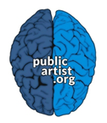
Submission Requirements

Applications must be received by the deadline via www.PublicArtist.org.

The application may be accessed directly at: https://bit.ly/2CmbPwN

Applications must include:
- a Letter of Interest, outlining the idea/installation, what sort of infrastructure is required (electrical, spatial dimensions, etc), and the thematic focus of the work;
- 10 images, videos or other file types (as defined in the application system) describing completed relevant artwork with descriptions;
- resume; and
- 3 professional references

The UNESCO Steering Committee encourages artists from various demographic backgrounds and geographic locations to apply, in order to select from a diverse pool of artists for public art commissions.

For technical assistance submitting your application online, please contact info@publicartist.org or 210-701-0775 (9:00 am – 5:00 pm CST). For questions about the artist opportunity or artwork criteria, please contact Cultural Arts Division staff at 512-974-7700.

UNESCO Austin Media Arts Applicant Pool

Applicants to this call who live within any of Austin’s ten council districts will have the option to be added to an applicant pool for an Austin UNESCO City of Media Arts Artist Roster that is currently in development. The artist roster will be used for upcoming opportunities related to the UNESCO City of Media Arts designation in Austin and in other UNESCO City of Media Arts cities.

Schedule
Installation of all works will take place the week of March 4, 2019. The closing date of the Exhibition is to be determined, but the desire is to have all works on view for the duration of the SXSW Interactive Festival, and potentially including the entire run of the 2019 SXSW festival.

September 5, 2018
Send out Invitational Request for Qualifications to Nominated Artists

October 19, 2018
Deadline for Applications through SXSW application system

October 15-31, 2018
UNESCO Steering Committee review qualifications and select artists/artist teams.

November 1, 2018
Artists are notified of acceptance.

November 2018 – February 2019
Fabrication of artworks by artists/Ongoing communication with staff from CAD and SXSW

Week of March 4, 2019
Artwork installation

By March 17, 2019 (this date to be confirmed)
De-installation of artwork

Contact/Questions
Kathleen Stimpert, Cultural Arts Division Arts Marketing Manager
(512) 974-7875 or Kathleen.Stimpert@austintexas.gov

About the Partners

About UNESCO Creative Cities
The UNESCO Creative Cities Network was created in 2004 to promote cooperation with and among cities that have identified creativity as a strategic factor for sustainable urban development. The 116 cities which currently make up this network work together towards a common objective: placing creativity and cultural industries at the heart of their development plans at the local level and cooperating actively at the international level.

About SXSW
SXSW dedicates itself to helping creative people achieve their goals. Founded in 1987 in Austin, Texas, SXSW is best known for its conference and festivals that celebrate the convergence of the interactive, film and music industries. The event, an essential destination for global professionals, features sessions, showcases, screenings, exhibitions, and a variety of networking opportunities. SXSW proves that the most unexpected discoveries happen when diverse topics and people come together. SXSW 2019 will take place March 9-18, 2019.

About the City of Austin Cultural Arts Division
The Cultural Arts Division of the Economic Development Department provides leadership and management for the City’s cultural arts programs and for the development of arts and cultural industries. The Cultural Arts Division is responsible for the Cultural Arts Funding Programs, Art in Public Places Program, community-based arts development, and programs to assist the development of film and creative industries in Austin.

