REQUEST FOR QUALIFICATIONS
DESIGN TEAM ARTIST (RFQ #00200)

DEADLINE TO APPLY: 5:00 PM, SEPTEMBER 4, 2020

CONTACT:
Emily Hanson, Purchasing Coordinator
San Antonio River Authority
ehanson@sariverauthority.org or 210-302-3605

Index
Call Summarry 3
Eligibility 3
Budget 3
Project Goals 3
Site Description 3
Selection Process 6
Selection Criteria 6
Timeline 6
How to Apply 6
Contact Information 7
Amendments to RFQ 7
Restrictions on Communications 7
Additional Policies 7

CALL SUMMARY
The San Antonio River Authority (River Authority) seeks to commission an artist to participate on a design team for the River Authority’s new campus in downtown San Antonio. The new campus is currently in the beginning phases of design and is scheduled to be complete in late 2021. It is also located within walking distance to the new San Pedro Creek Culture Park and the award-winning River Walk along the San Antonio River.
The selected artist is expected to work closely with River Authority staff and its consultants to develop an interactive and educational component as part of a prominent Low Impact Design (LID) feature at the entrance to the main facility. Other opportunities may arise depending on the direction of the overall campus design.
More information about the San Antonio River Authority can be found at www.sariverauthority.org.

ELIGIBILITY
This opportunity is open to all professional artists residing in the United States. Artists must have prior experience participating on design teams of a similar scope and must have knowledge of environmentally friendly design principals, like LID.

BUDGET
The budget for this opportunity is up to $8,000. The selected artist will be paid per hour with the anticipation of 60-75 hours over six months. Travel to San Antonio is not required however, if desired by either the River Authority or the selected artist, accommodations would be paid by a separate budget. All other costs are inclusive of the artist’s per hour fee.

PROJECT GOALS
The goals of this collaborative effort are to:
- Incorporate the perspective of an artist into the design of a new River Authority campus;
- Educate the public about environmentally friendly design solutions;
- Create excitement and interest from the community and facility visitors; and
- Celebrate the accomplishments of the River Authority through artistic expression.

SITE DESCRIPTION
The River Authority’s new campus is located in San Antonio’s growing Southtown neighborhood in the site formerly owned by Alamo Colleges District, near the River Authority’s iconic headquarters on Guenther St. The new campus will serve as a figurative connection between the San Pedro Creek Culture Park and the River Walk on the San Antonio River, two award-winning projects that have provided the River Authority with international acclaim.
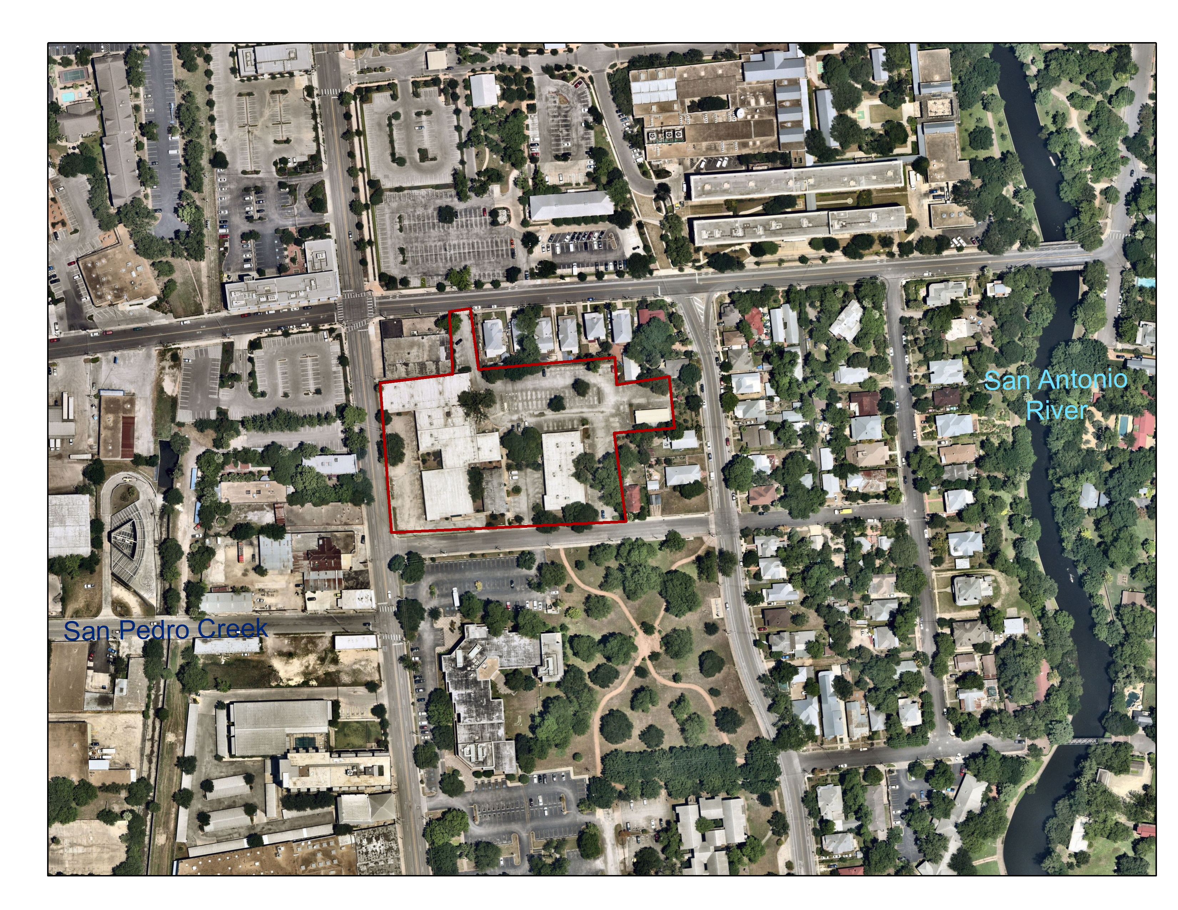
New campus outlined in red with the San Antonio River to the right and San Pedro Creek (section currently under development) to the left. The recessed courtyard is outlined in yellow.

The campus will feature office space, laboratory facilities, public meeting space, and other organization support. The campus will also be retrofitted with stormwater management features and updated landscaping in order to manage stormwater runoff onsite in a sustainable manner to improve the water quality of San Pedro Creek and San Antonio River. Stormwater best management features such as cisterns, bioretention and bioswales, and a green roof bus-stop. The goal of the River Authority is to use these features to showcase how these development approaches and landscaping with native plants species can be used within the San Antonio River Basin. As such the River Authority intends to add an educational element to the incorporation of BMPs to the campus. Landscaping will utilize native plant species and reflect the different bio-regions of the San Antonio River Basin.
Design of the stormwater retrofit has started and is anticipated to be complete by December 2020. The stormwater retrofit project is concurrent with the overall campus redesign. Throughout the process, River Authority staff will be operating throughout the campus.
The primary focus of this solicitation will be at the “front door” of the campus, where most of the public will enter. This area is a recessed courtyard area. The current design incorporates a cistern to capture runoff from the building rooftops and eventually routed to landscaping. The goal is to create an artistic interactive component that educates visitors to the public on the dynamics and impacts of stormwater runoff or other components of watershed function. With the integration of an artistic element to the stormwater BMP, the River Authority intends to create a sense of place, welcoming visitors to the campus and serving as a seamless transition between San Pedro Creek and San Antonio River.
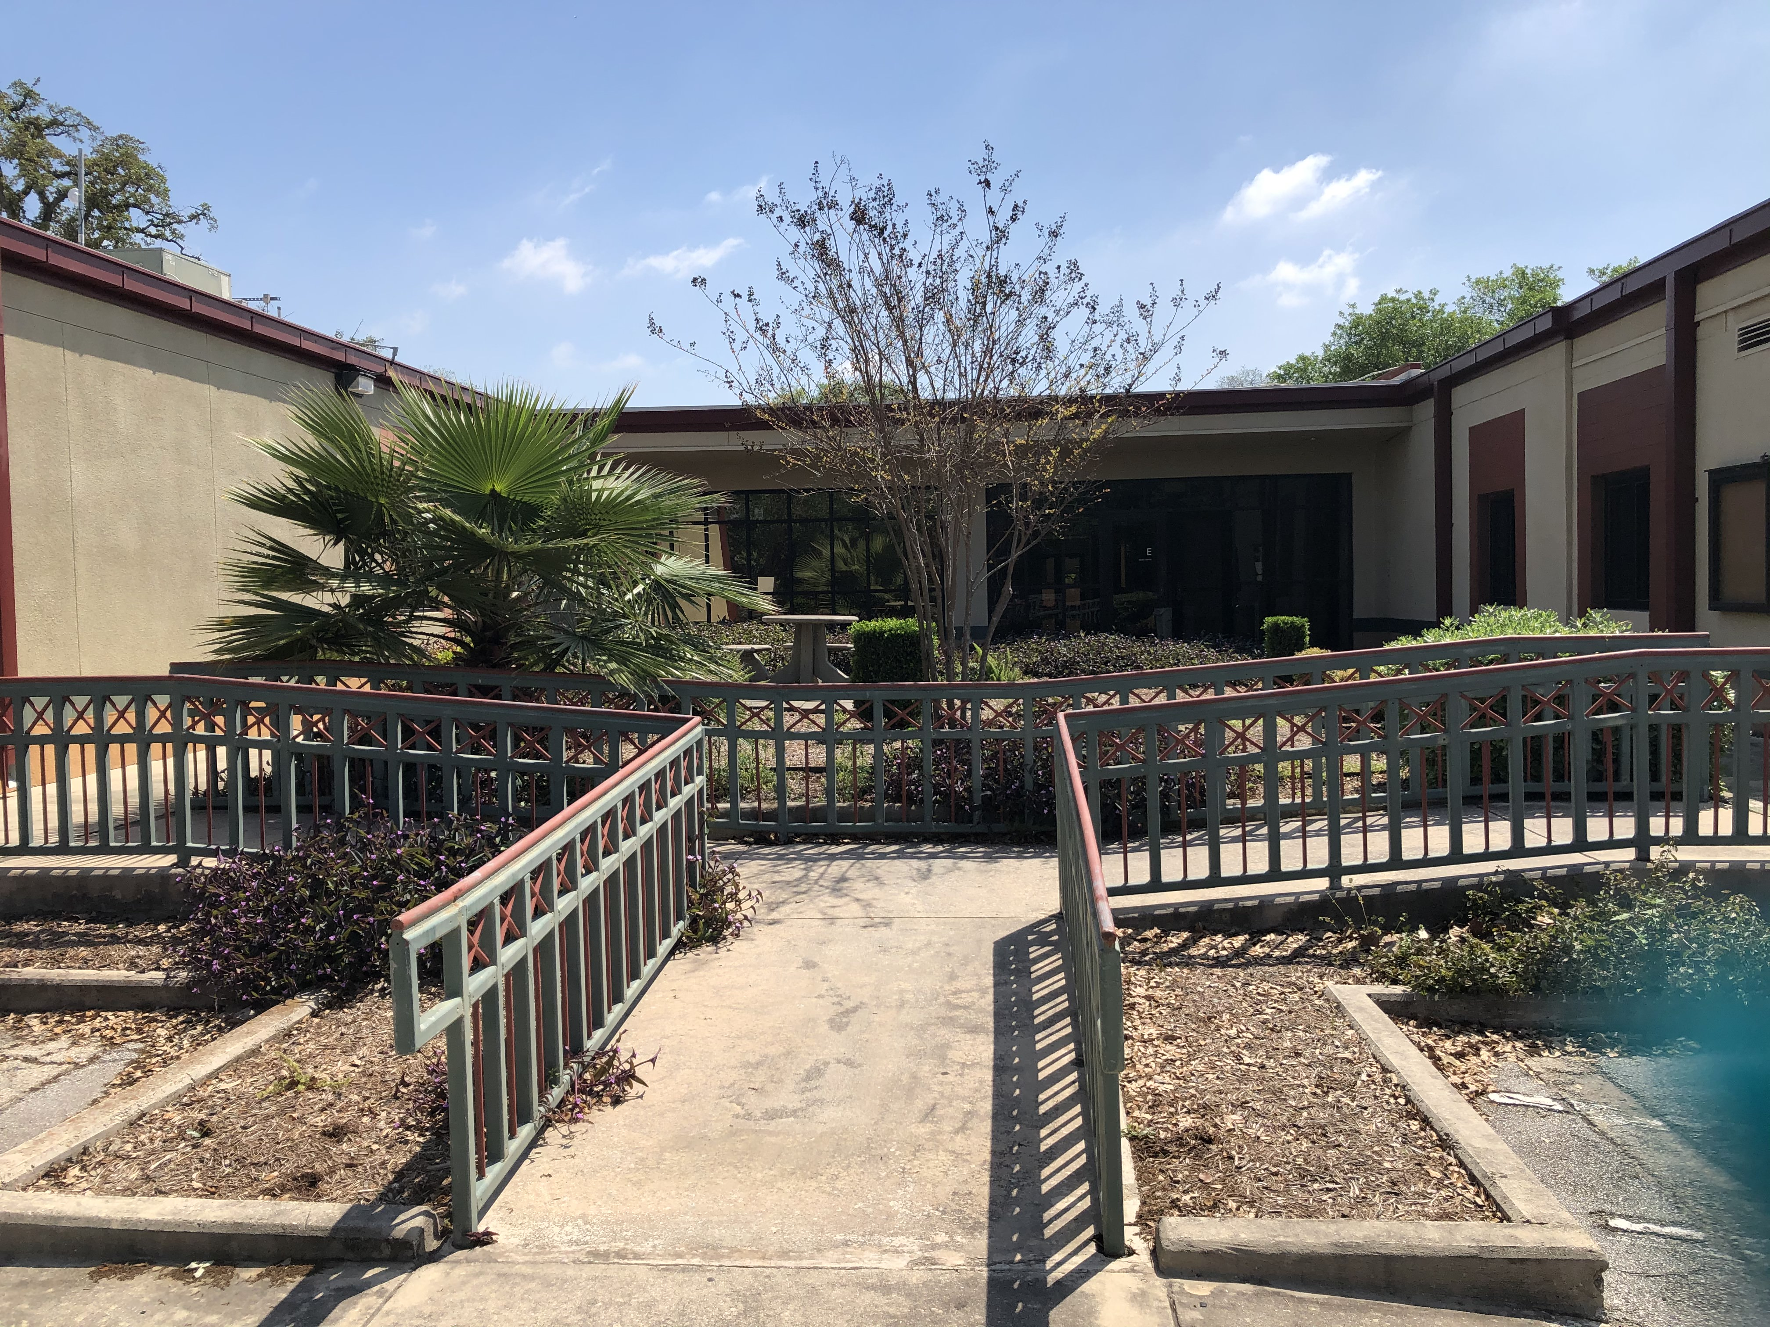
Views of the recessed courtyard in its current condition
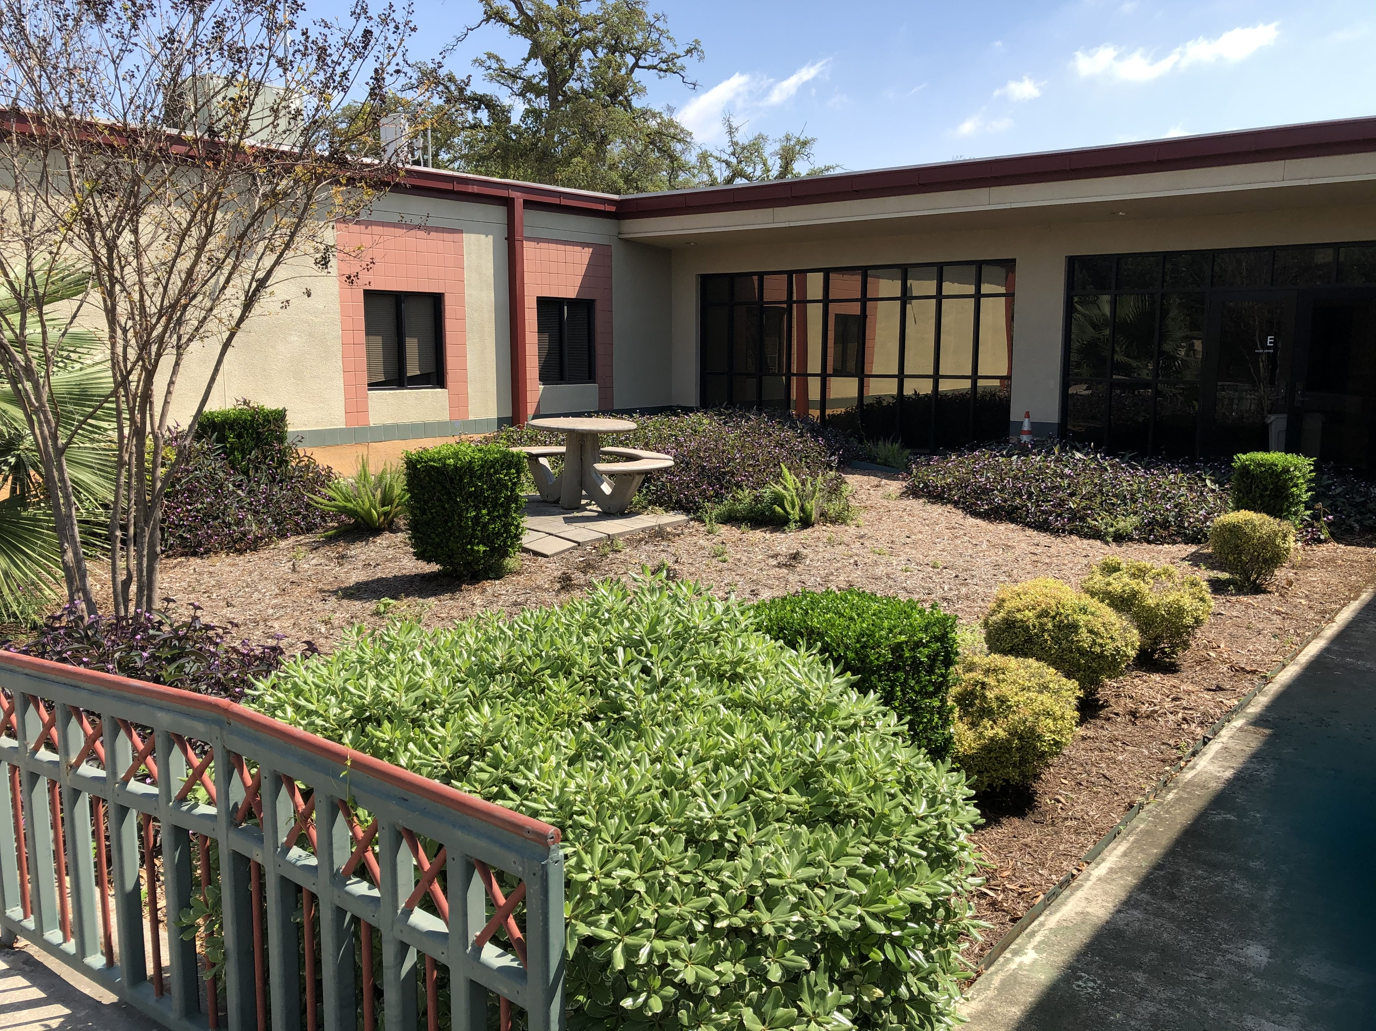
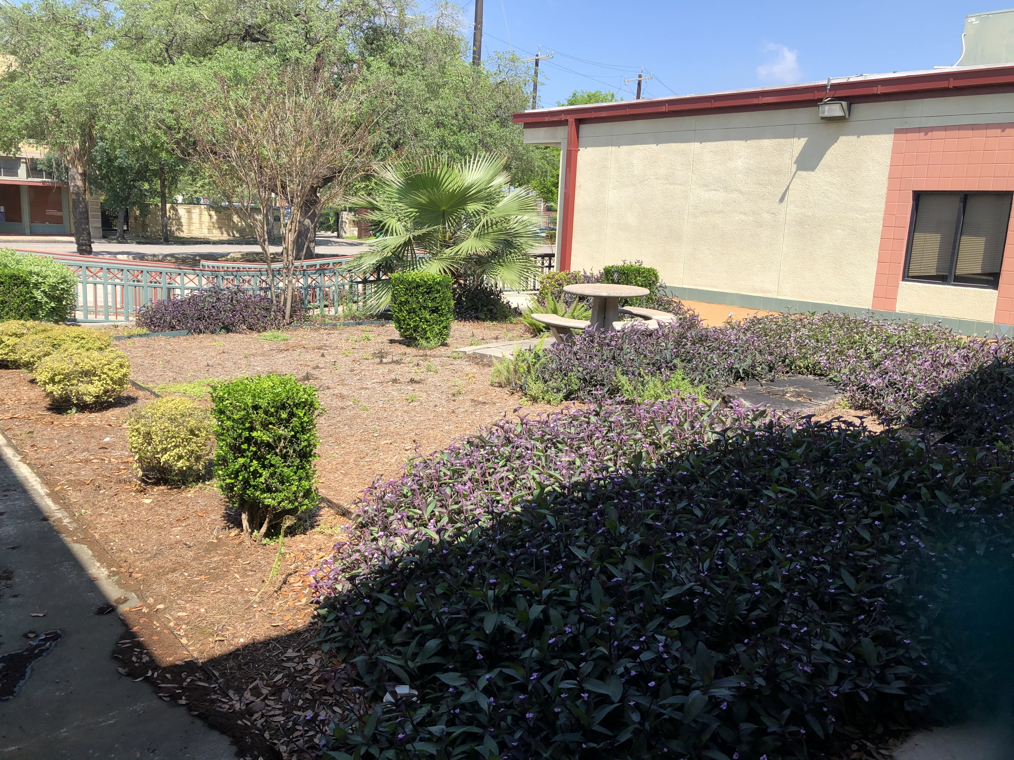

SELECTION PROCESS
The River Authority is administering the artist selection process for this opportunity and will convene a selection panel made up of River Authority staff including the public art curator, watershed engineers, designers and executive team members. The selection panel will review and evaluate the applications received and select an artist based on submissions to this RFQ. Finalists may be selected and interviewed before a decision is made.

SELECTION CRITERIA
Artists should demonstrate the following:
- Artistic merit and relevant body of work (40%);
- Experience completing a project of similar scope (design team collaboration) (30%);
- Demonstrated knowledge of environmentally friendly design solutions (20%); and
- Expressed interest in creating a collaborative work of art for the River Authority campus (10%).

TIMELINE (dates may be adjusted at any time)
2020
August 12, 2020 Request for Qualifications issued
August 26, 2020, 5pm Deadline to submit questions
September 4, 2020 Request for Qualifications deadline
Week of September 7, 2020 Selection Panel reviews applications and selects artist
September 2020 Contract negotiation
October 2020 – March 2021 Design Team collaboration (exact schedule TBD)
Late 2021 Construction complete

HOW TO APPLY
Artists interested in being considered should submit the following materials no later than 5:00 pm (Central Time) on August 26, 2020, through www.PublicArtist.org, an online application system. The following application materials are required:
- Letter of interest. The letter should be no more than one page in length and should explain your interest in participating in this opportunity.
2) Resume. Indicate your commissions, exhibitions, awards, publications and education.
3) 10 samples of past work with annotated image/video description including title, date, size, medium, location, budget, and if a commissioned project, the commission agency.
4) References. At least one signed letter of recommendation from a previous collaborator that has a thorough understanding of your work and working methods.
There is no application fee to use the www.PublicArtist.org online application system. Applicants can receive support by contacting www.PublicArtist.org at info@publicartist.org or 210-701-0775 (9:00 am – 5:00 pm Central Time). Applications mailed or delivered to the River Authority will be considered ineligible and will not be accepted.
CONTACT INFORMATION
If you have any questions regarding this request for qualifications, please contact Emily Hanson, Purchasing Coordinator, San Antonio River Authority, at 210-302-3605 or ehanson@sariverauthority.org.

AMENDMENTS TO RFQ
Should an amendment to this RFQ become necessary, it will be provided to artists with all answers to questions received about this RFQ. It is the sole responsibility of any artist interested in submitting qualifications to check their email for amendments. If the artist does not have access to the internet, they must contact Emily Hanson to inquire.

RESTRICTIONS ON COMMUNICATION
Once the RFQ has been released, artists are prohibited from communicating with the River Authority elected officials and staff and members of the Design Team regarding the RFQ, with the following exceptions:
- Questions concerning substantive RFQ issues shall be directed, electronically only, to ehanson@sariverauthority.org. Verbal questions and explanations are not permitted other than for general non-substantive issues or as may be described by this section and during interviews, if any. No inquiries or questions will be answered if received after 5:00 pm Central Time on August 26, 2020, to allow ample time for distribution of answers and/or amendments to this RFQ. Artists wishing to receive copies of the questions and their responses must notify Emily Hanson in writing prior to the date and time the questions are due.
- Currently contracted vendors may communicate with River Authority staff in order to continue working on active matters, but such communication shall not include discussions regarding this RFQ.
- The River Authority reserves the right to contact any artist for clarification after responses are opened and/or to further negotiate with any artist if such is deemed desirable.

ADDITIONAL POLICIES
- The River Authority has the discretion to disqualify artists whose applications are late or incomplete, and whose applications do not comply with all stated requirements.
- The River Authority reserves the right to select one, more than one, or no applicants in response to this RFQ.
- The River Authority may accept any Proposal in whole or in part. If subsequent negotiations are conducted, they shall not constitute a rejection or alternate RFQ on the part of the River Authority.
- The River Authority reserves the right to accept or to reject any or all proposals received in response to this RFQ, and to waive informalities and irregularities in the proposals received. The River Authority also reserves the right to terminate this RFQ, and reissue a subsequent solicitation, and/or remedy technical errors in the RFQ process.
- No work shall commence until a mutually acceptable contract document(s) is signed by the River Authority and the selected artist provides the necessary evidence of insurance as required in this RFQ and the Contract. Contract documents are not binding on the River Authority until reviewed by legal counsel. In the event the parties cannot negotiate and execute a contract within the time specified, the River Authority reserves the right to terminate negotiations with the selected artist and commence negotiations with another artist.

***END***

