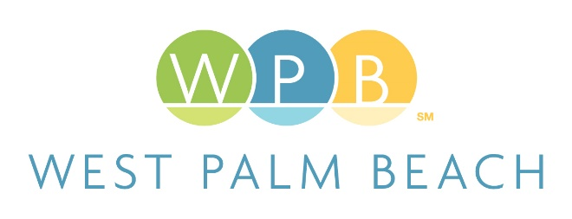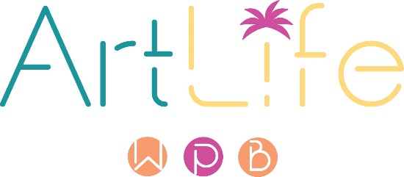

CALLING ALL PALM BEACH COUNTY ARTISTS!
The Commons: 10 Artists in 10 Spaces
Public Art Initiative: The Return to Play
The City of West Palm Beach’s ArtLife Committee is dedicated to supporting the local creative sector by providing opportunities to create art in the public realm. The Committee will select 10 professional artists who reside in Palm Beach County for The Commons Project (“Project”).

Eligibility:
Open to professional visual and multimedia artists over 18 years of age who reside in Palm Beach County. Proof of residency will be required. Applicants’ residency will be verified.

Application Deadline:
August 10, 2022: Deadline to submit resume, proof residency, and video.
Submit to: http://publicartist.org/call.cfm?id=6166

Curatorial Vision:
Ten multidisciplinary artists will be commissioned to create temporary artworks that engage the community and incorporate “play” as the central theme. It is through play that we experience the world. Play allows us to understand ourselves and one another outside of the structures of society. Taking the endless possibilities of “being playful” we encourage artists to create in our public spaces with “play” as the inspiration.

Goal:
The Project will provide an opportunity for local artists to further their practice while receiving monetary relief.
Project Total Budget: $100,000

Ten artists to receive up to $10,000 each. Each award will include a not to exceed $2,000 artist fee and the remaining balance of $8,000 (not to exceed) on design, materials, build and installation. (Invoices/documentation required for the materials and installation)
Materials, Media, and Locations:

The City seeks artists of all media to create and reimagine in the City’s public spaces. One of the ten awards will be a time-based artist that will capture The Commons Project.
Available public spaces or sites include, but are not limited to, Jose Marti Park, City Hall plaza, Northwood Village, Currie Park, Flagler Drive, Mandel Public Library, The Chamber of Commerce exterior wall or conceptually as performance, in written form, as a (new media) video game redefining what public spaces mean to us and the platform they provide to connect.
Media sites or locations will be subject to several conditions, with public safety as top priority. City staff will work closely with the selected artists to ensure that the selected sites meet the goals of the Project; are feasible to use; and do not pose a health or public safety hazard.
Application and Selection Process:

Step 1: Application

All applicants must submit a current professional resume (not to exceed two pages) that confirms them as professional artists as defined in the City’s Code of Ordinances and which includes the applicants’ residential address in Palm Beach County. The top line of the applicant’s resume must include the applicant’s full name and physical mailing address. P.O. Boxes will not be accepted and will be disqualified. Along with their resumes, applicants shall submit (2) documents to prove their residency. Such documents may include but not be limited to utility bills, voter registration, property appraiser records, leases, etc.

An up to three-minute video explaining the artist’s art practice and how having an opportunity to create in the public realm will advance the artist’s work. Further, each artist should include the idea of play within the artist’s work or as an opportunity to experiment. Applicants with videos exceeding the three- minute limit will automatically be disqualified.

The City is NOT seeking proposals at this application stage. The video is a means to discuss the Artist/Applicant and the Artist/Applicant’s work, practice and approach to the project’s theme if selected.
Submit to http://publicartist.org/call.cfm?id=6166

Once the application period is closed, the ArtLife Committee will review all qualifying video submissions and select 10 artists. Applicants with proposals will be disqualified.
Step 2: Selection

The selected 10 artists will develop proposals for the ArtLife Committee’s review and recommendation to the City Commission. Final approval is with City Commission.
The ArtLife Committee will consider the following criteria when reviewing the proposals:

- Relation to theme.
- Cultural impact.
- Quality.
- Appropriateness to site.
- Compatibility.
- Public welfare.
- Diversity in medium.
- Artist qualifications.

Guidelines:

The selected artists will have an opportunity to create a temporary artwork not to exceed 18 months, however, the work may be shorter in length or on exhibit. The selected artists will be required to sign a contract with The City of West Palm Beach. Public safety is of utmost importance and the selected artists will work closely with City staff during the proposal, installation and/or activation stages.

Concepts must be sensitive to racial, cultural, religious, and political opinions. The project should address the theme of “play.”
Timeline:
June 29, 2022: Call published
August 10, 2022: Deadline to submit videos
TBD: ArtLife review applicants and select 10 artists

For more information please email scwelter@wpb.org – subject line The Commons 2022-23

DISCLAIMER
Proposers should rely exclusively on their own site investigations for development of proposals, concepts and means and methods of installation/fabrication. This Call to Artists is being provided by the City without any warranty or representation, expressed or implied, as to its content, accuracy or completeness and no proposer or other party shall have recourse to the City if any information herein contained shall be inaccurate or incomplete.
This Call is made subject to correction of errors, omissions, or withdrawal without notice.
No warranty or representation is made by the City that any proposal conforming to these requirements will be selected for consideration, negotiation, or approval. The City is under no obligation to award a commission for artwork based on the proposals submitted. The City may withdraw or cancel this Call at any time without any liability or obligation on the part of the City or the City’s ArtLife Committee. In its sole discretion, the City, through its ArtLife WPB Committee may determine the qualifications of any artist submitting proposals. The City and Proposer will be bound only when a proposal, as it may be modified, is approved, and accepted by the City and the applicable contract is approved by the City Commission and executed and delivered by the artist and the City.

